2016

SOFTWARE

DEVELOPMENT PLAN

(SDP)

HERBAL MOBILE APPS (HMA)

AHMAD SOLEHIN BIN SHARUDDIN(CB15003)



**SOFTWARE DEVELOPMENT PLAN (SDP)** FSKKP

**MBER VERSION NUMBER (*Example SDP ABC 2008 VERSION 1.0*)** i

KAMAL WAL MUKAMMAL BIN ABD RAHIM (CB15015)

GRACE SHEELA A/P MOGAN (CB16003)

NUR SYUHAIDAH BT ISMAIL(CB17006)

QATHRATUN NADA BT ALI (CB16012)

[SKITZA CORP]

To be submitted to the Software Planning & Requirement Workshop

Bachelor of Computer Science (Software Engineering)

**TABLE OF CONTENTS...................................................................................................................... ii LIST OF FIGURES............................................................................................................................... iii LIST OF TABLES ................................................................................................................................. v**

**1. INTRODUCTION......................................................................................................................... 1**

1.1 PROJECT IDENTIFICATION ............................................................................................. 1

1.2 PROJECT OVERVIEW ........................................................................................................ 1

1.3 PROJECT DELIVERABLES ................................................................................................ 3

**2. SOFTWARE DEVELOPMENT……………………................................................................. 4**

2.1 PROJECT ORGANIZATION……………………................................................................ 4

2.2 PROJECT RESOURCES...................................................................................................... .7

2.3 PROCESS MODEL….......................................................................................................... .9

2.4 RISK MANAGEMENT……................................................................................................ 14

2.5 SECURITY AND PRIVACY............................................................................................... 15

2.6 CORRECTIVE ACTION PROCESS................................................................................... 16

**3. SOFTWARE ENGINEERING ................................................................................................... 17**

3.1 SOFTWARE ITEMS ........................................................................................................... 17

3.2 HARDWARE ITEMS………………………………............................................................ 18

3.3 SOFTWARE EVALUATION.............................................................................................. 18

**4. NOTES......................................................................................................................................... 19**

**5. APPENDICES………………………………………………………………….……………… 20**

**LIST OF FIGURES**

Figure 2.1 Project Organizational Structure .................................................................................... 4

Figure 2.2 Internal Management Organizational Structure ............................................................. 5

Figure 2.3 Waterfall Model ............................................................................................................. 9

Figure 2.3.1 Schedule...................................................................................................................... 11

Figure 2.3.1 Gantt Chart….…………………………. ..................................................................... 11

**LIST OF TABLES**

Table 1.1 Software to be Delivered .................................................................................................. 2

Table 1.2 Project Deliverable …………………………………………........................................................ 3

Table 2.1 Roles and Responsibilities ................................................................................................. 6

Table 2.2 Budget Allocation.............................................................................................................. 7

Table 2.3 Risk Analysis………………………………. ................................................................... 15

Table 3.1 Software Item ……………………………………………............................................................ 17

Table 3.2 Hardware Item………….. ................................................................................................ 18

Table 4.1 Definition of Term ............................................................................................................ 19

**LIST OF APPENDIXES**

**Appendix A ....................................................................................................................... 20**

Appendix A-1 .................................................................................................................................. 21

Appendix A-2 .................................................................................................................................. 21

**Appendix B ....................................................................................................................... 22**

Appendix B-1 .................................................................................................................................. 23

**1. INTRODUCTION**

* 1. **PROJECT IDENTIFICATION**

System Title: Herbal Mobile Apps

System Abbreviation: HMA

System ID: SKITZA – HMA – 01

* 1. **PROJECT OVERVIEW**

**1.2.1 Project Summary**

This section of the document is an introduction SKITZA Corporation proposal to complete the software development portion of the Herbal Mobile Apps (HMA) project. It will describe the objective that are to be accomplished, the software to be delivered that underlie the effort and the deliverables that will be produced by the project.

**1.2.2 Objectives**

The objectives of the project are as follows:

1. to give some information about traditional herbal .
2. find a way to cure disease.
   * 1. **Software to be delivered**

The table below indicates all the software that will be used to build the Herbal Mobile Apps (HMA).

**Table 1.1** Software to be delivered

|  |  |
| --- | --- |
| **Software** | **Purpose** |
| Microsoft Windows Operating System  • Windows 7 Professional | • As a platform for a system to run  • Operating system which will be used to develop the system |
| Microsoft Office  • Microsoft Word 2007 & 2010  • Microsoft Project 2007  • Microsoft Visio 2010 | • Prepare proposal and documentation  • Create Gantt Chart  • Design and draw chart and diagram |
| Relational Software Architect | • Design and draw use case and sequence diagram |
| Phonegap Cordova, Sublime 3,  Adobe Photoshop, Node Js | • Design interface and generate coding |
| MySQL, PHP myadmin, Cpanel | • Database for the system; generate database, database management and database platform |
| WinRAR | • Compress project files |

* 1. **PROJECT DELIVERABLES**

**Table 1.2** Project Deliverables

|  |  |  |
| --- | --- | --- |
| **Product** | **Delivery Date** | **Delivery Method** |
| Initial plan | 11/11/15 | Hardcopy |
| Software Requirements Specifications (SRS) | 20/11/15 | Hardcopy |
| Software Development Plan (SDP) | 23/12/15 | Hardcopy |
| Database | 12/2/16 | CD |
| System (Source and Object Code) | 12/3/16 | CD |
| Software Testing Descript | 26/3/16 | Hardcopy |
| System Launching | 30/4/16 | CD |

**2. SOFTWARE DEVELOPMENT MANAGEMENT**

**2.1 PROJECT ORGANIZATION AND RESOURCES**

**2.1.1 Project Organizational Structure**

|  |
| --- |
| STEERING COMMITTEE  AHMAD SOLEHIN |

|  |
| --- |
| PROJECT DIRECTOR/WORKING COMMITTEE  KAMAL WAL MUKAMMAL BIN ABDUL RAHIM |

|  |
| --- |
| PROJECT MANAGER  AHMAD SOLEHIN BIN SHARUDDIN |

|  |
| --- |
| COMPANY CO-ORDINATOR  KAMAL WAL MUKAMMAL BIN ABDUL RAHIM |

QUALITY ASSURANCE MANAGER

QATHRATUN NADA BINTI ALI

SOFTWARE DESIGNER

GRACE SHEELA A/P MOGAN

BUSINESS ANALYST

NUR SYUHAIDAH BINTI ISMAIL

SOFTWARE DEVELOPER

KAMAL WAL MUKAMMAL BIN ABDUL RAHIM

**Figure 2.1** Project Organizational Structure

**2.1.2 Internal Management Organizational Structure**

SKITZA Corporation (SKITZA Corp) was formed in October 2015. Our company located in University Malaysia Pahang, Lebuhraya Tun Razak, 26300, Kuantan Pahang. SKITZA Corp contains five members that is Ahmad Solehin Bin Sharuddin as a project manager, Nur Syuhaidah Binti Ismail as a business analyst, Kamal Wal Mukammal bin Abdul Rahim as a software developer, Grace Sheela A/P Mogan as a software designer and Qathratun Nada Binti Ali as a quality assurance.

**Figure 2.2** Internal Management Organizational Structure

**2.1.3 Organizational Boundaries and Interface**

**Table 2.1** Roles and Responsibilities

|  |  |  |
| --- | --- | --- |
| **Roles** | **Responsibilities** | **Name** |
| Project Manager | Responsible for planning execution, coordination of team members, communication with the acquirer , consultant and customer, closing of the project | Ahmad Solehin |
| Business Analyst | Acts as a bridge between the business and IT, translating the business’s requirement into a form that can be understood by the system developer’s. | Nur Syuhaidah Binti Ismail |
| Software Designer | Responsible for making architecture, database, data, object and user interface design. | Grace Sheela A/P Mogan |
| Software Developer | Responsible for analyzing requirements, preparing documentation and implementing of the software. | Kamal Wal Mukammal Bin Abdul Rahim |
| Quality Assurance Manager | Ability for analyzing requirements of the products which meets with the specified requirements and customer expectations. | Qathratun Nada Binti Ali |

**2.2 Project Resources**

* Budget Allocation Plan

**Table 2.2** Budget Allocation

|  |  |  |
| --- | --- | --- |
| **Task Name** | **Duration (hour)** | **Costs (RM)** |
| **Project Management** |  |  |
| **Initial Plan** |  |  |
| Meeting with customer | 16 | 350.00 |
| Meeting with Acquirer | 40 | 400.00 |
| Preparation of Initial Plan | 50 | 100.00 |
| Revision of Initial Plan | 48 | 100.00 |
| **SDP** |  |  |
| Discussion about topic | 24 | 40.00 |
| Managerial Process Plan | 40 | 300.00 |
| Technical Process Plan | 56 | 200.00 |
| Supporting Process Plan | 64 | 100.00 |
| Preparation of SDP | 32 | 100.00 |
| Revision of SDP | 40 | 100.00 |
| **Risk Management** |  |  |
| Identification of Risk Factors | 48 | 500.00 |
| Analysis of Risk Factors | 96 | 600.00 |
| Prioritization of Risk Factors | 64 | 650.00 |
| Monitor of Risk Factors | 42 | 700.00 |
| **Requirement Analysis** |  |  |
| Discussion | 40 | 50.00 |
| Requirement Elicitation | 46 | 50.00 |
| Analysis of Requirement | 35 | 60.00 |
| Preparation of SRS | 50 | 100.00 |
| Revision of SRS | 25 | 100.00 |
| **Design** |  |  |
| Discussion | 40 | 50.00 |
| Gui Design | 50 | 1000.00 |
| **Data Design** |  |  |
| Data Structure Design | 80 | 1500.00 |
| Database Design | 50 | 1500.00 |
| Object Design | 50 | 1500.00 |
| Preparation of SDD | 70 | 100.00 |
| Revision of SDD | 25 | 100.00 |
| **Implementation** |  |  |
| Development of DB | 80 | 3000.00 |
| Coding | 95 | 5000.00 |
| **Testing** |  |  |
| Unit / Integration Testing | 80 | 800.00 |
| System testing | 40 | 1000.00 |
| Acceptance Testing | 55 | 500.00 |
| **TOTAL** | 1571 | 20,650.00 |

**2.3 PROCESS MODEL**

Throughout the whole software development process, our development team uses Waterfall mode. Waterfall process model is a linear model thus easy to be implemented. Deliverables are clearly seen throughout the whole development process, from each phase to the next phase. Documentations are produced at the end of every stage of waterfall model development which makes the product development is simpler.

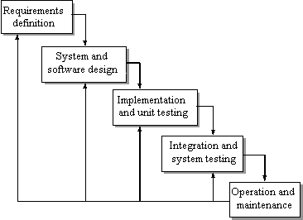

**Figure 2.3** Waterfall Model

**Requirements definition**: Requirements and related information are gathered during this phase. The functionalities and constraints of the system are also determined to avoid future problems. Requirements are gathered from the end user through consultation to check for validity.

**System and software design:** System design helps to specify hardware and system requirements. Designing is also crucial to define overall system architecture. This must be done before proceeding with the real coding to avoid any useless mistakes happen in the next phase. System design documents are created at the end of the phase.

**Implementation and unit testing:** Implementation starts once receiving system design documents. Here, works are delegated in several main modules and actual coding is started. Each of the system part is developed and tested for its functionality. Unit testing will validate and verify as if the modules meet their specifications.

**Integration and System Testing:** In the previous implementation and unit testing phase, the units are developed and tested by modules for its functionality. In this phase, all the modules are integrated and tested as one complete system purposely to check as if the modules are coordinated between each other. Once successfully done, the system will be delivered to the customer.

**Operation and Maintenance:** After the deliverables, any issues related to the system which unable to be found during the development process will be monitored and maintained by the developing team. Rare problems are hardly appear at the early deployment stage and they usually rise after some time, thus a continuous maintenance are needed to solve these problems.

**Why use waterfall model?**

* Being a linear model, it is very simple to implement.
* The amount of resources required to implement this model are minimal.
* Documentation is produced at every stage of the software's development. This makes understanding the product designing procedure, simpler.
* After every major stage of software coding, testing is done to check the correct running of the code.

The entire storyline of the system will be finalized before the coding begins. Therefore we have a clear idea as to what we want. Moreover we would know how good our system is and what scenarios the system will be handling.

**2.3.1 Schedule and Gantt Chart**

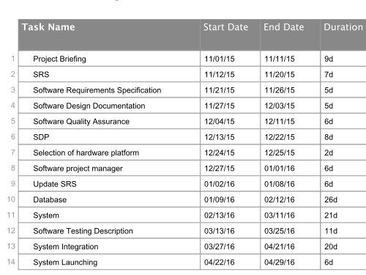

**Figure 2.3.1** Schedule

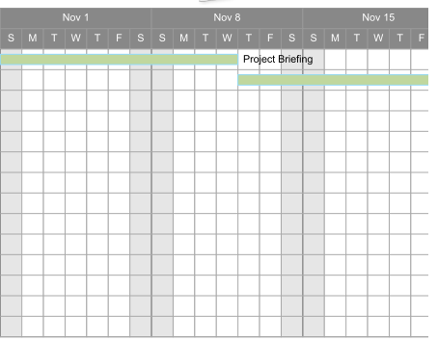

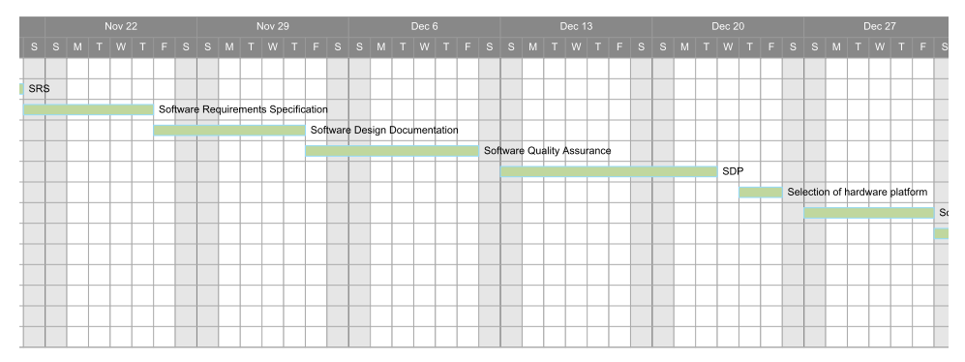

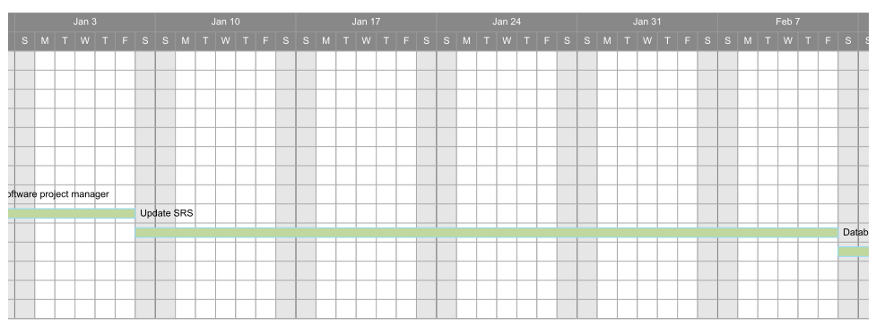

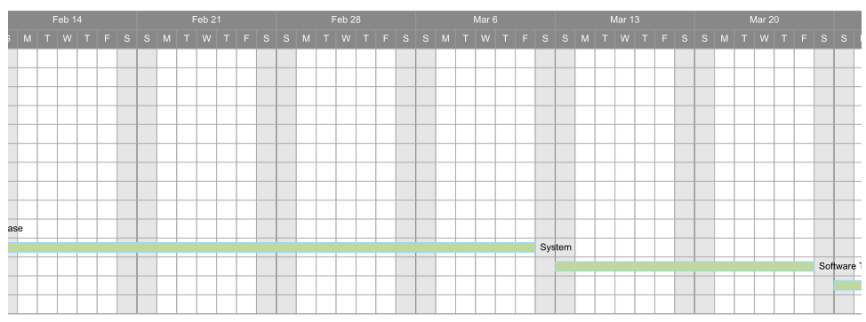

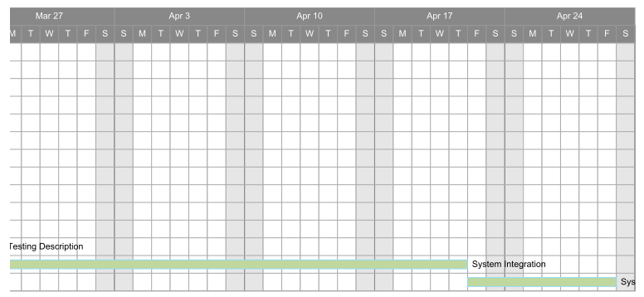

**Figure 2.3.1** Gantt Chart

**2.4 RISK MANAGEMENT**

The purpose of the Risk Management is to identify, analyze and rank risk factors. Once factors have been identified then these will be analyzed for impact and consequences and ranked accordingly plans will be put in place for contingencies and tracking and control measures will be put in place. Risk management is an ongoing task, as influencing conditions a rarely stagnant during the course of the project.

**2.4.1 Risk Identification**

The risks will be listed, updated, and monitored in this section.

Risk # 1: The users of the application are not entirely sure what they want or need.

Risk # 2: The developers have little knowledge about traditional herbal.

Risk # 3: The development of system lack of team member.

**2.4.2 Risk Analysis**

**Table 2.4** Risk Analysis

|  |  |  |
| --- | --- | --- |
| **RISKS** | **PROBABILITY** | **IMPACT**  **1(low) – 5(high)** |
| Quality of product documentation and coding are not suitable | %35 | 3 |
| Timing Problem | %15 | 4 |
| Health problem | %35 | 1 |
| Mistake in coding | %15 | 4 |
| System may be not work | %15 | 4 |

* FEP Memory Overrun – In case the memory of the buffer is not enough for the amount of data that is being received, it would result in a memory over run of the Front End Processor. Due to its Severity is analyzed to be **High**. To avert this, we can increase the number of test cases to come up with an adequate buffer size. Also, prototyping would prevent this defect.
* Synchronization Issues – If the sender and the receiver are not synchronized, it could end up into retrieval of data loss. Thus its severity is evaluated to be **High**.

This fault can be avoided by proper simulation and reliable estimation.

* Security Risk – HMA does not have auto logout. So other people can use the account if the user not logout from the system.
* Unsatisfactory GUI – The satisfaction of the user-friendliness of the GUI is an important requirement. There is a risk that the GUI would be substandard. Hence, the severity of this is **Moderate**.
* Cost Overruns – It is extremely important to complete the project in a timely fashion and within the allotted budget. Cost overrun could be fatal for the project. Thus, its severity is **High**.

**2.5 SECURITY AND PRIVACY**

In Herbal Mobile Apps (HMA) user does not need to login to enter the system. User need to download this apps in Playstore,App Store and Google Store.

**2.6 CORRECTIVE ACTION PROCESS**

**Backup Data**: How we backup our client database from lost data or costly system downtime.

* Optimizing the server for performance which includes, space management, monitoring memory usage, and diagnosing problems.
* Administering the server on a daily basis to ensure server availability and the ongoing health of the system.
* Disaster prevention and recovery including creating consistent backups and restoring databases in case of network, application, or hardware failure.

**3. SOFTWARE ENGINEERING**

**3.1 SOFTWARE ITEMS**

**3.1.1 Software Items**

The table below indicates all the software that will be used to build the Herbal Mobile Apps (HMA).

**Table 3.1** Software Items

|  |  |
| --- | --- |
| **Software** | **Purpose** |
| Microsoft Windows Operating System  • Windows 7 Professional | • As a platform for a system to run  • Operating system which will be used to develop the system |
| Microsoft Office  • Microsoft Word 2007 & 2010  • Microsoft Project 2007  • Microsoft Visio 2010 | • Prepare proposal and documentation  • Create Gantt Chart  • Design and draw chart and diagram |
| Relational Software Architect | • Design and draw use case and sequence diagram |
| Phonegap Cordova, Sublime 3,  Adobe Photoshop, Node Js | • Design interface and generate coding |
| MySQL, PHP myadmin, Cpanel | • Database for the system; generate database, database management and database platform |
| WinRAR | • Compress project files |

**3.2 Hardware Items**

**Table 3.2** Hardware Items

|  |  |
| --- | --- |
| **Hardware** | **Purpose** |
| Laptop Computer | Device to develop and create the system |
| Server | To test and run the system in localhost |

**3.3 SOFTWARE PRODUCT EVALUATION PROCEDURES AND TOOLS**

This section describes the approach to be followed for software product evaluation

**3.3.1 Evaluation Procedures**

This section will identify and describes the procedure that will be used to evaluate and inspect the software and associated documentation.

* Decision Analysis Spreadsheet

**3.3.2 Evaluation Tools**

This section will identify and describes the tools that will be used in the software product inspection

* Not Applicable

**3.3.3 Independence in Software Product Evaluation**

This section describes thedetail of software’s product evaluation procedures.

* Not Applicable

**4. NOTES**

**Table 4.1**: Definition of Term

|  |  |
| --- | --- |
| **Term** | **Definition** |
| RFP | Request for Proposal |
| SRS | Software Requirements Specification |
| SQAP | Software Quality Assurance Plan |
| STP | Software Testing Plan |
| SDS | Software Design Specification |
| SCMP | Software Configuration Management Plan |
| SVVP | Software Verification and Validation Plan |
| Project deliverable | A work product to be delivered to the acquirer |
| PHP | Hypertext Preprocessor |
| IT | Information Technology |
| HMA | Herbal Mobile Apps |

APPENDICES

**APPENDIX A**



**Appendix A-1** Schedule



**Appendix A-2** Gantt Chart

**APPENDIX B**



**Appendix B-1** Company Logo